[1]

CmpE 124 Lab 4: Mixed-Logic Circuit Design

Anahit Sarao, 008435583, Cmpe 124 Spring 2016, Lab Section 6

*Abstract*—This labs purpose was to create two new types of logical circuits, a multiplexor and decoder. By deriving equations from given voltage tables the combinational circuits were constructed. Logic Works software was used to confirm if the circuits produced the correct results.

# INTRODUCTION

To study the usage and behaviors of multiplexors and decoders two different voltage table are provided. From the tables the Boolean equations can be derived and a logical circuit can be made. The importance of these circuits from the previous is that they are combinational circuit and not sequential circuits.

# Design methodology

## Parts List

* 74LS10
* 74LS20
* 74LS04

## Truth Tables

|  |  |  |  |
| --- | --- | --- | --- |
| Truth Table for 74LS10 3-Input NAND Gate | | | |
| X | Y | Z | F |
| 0 | 0 | 0 | 1 |
| 0 | 0 | 1 | 1 |
| 0 | 1 | 0 | 1 |
| 0 | 1 | 1 | 1 |
| 1 | 0 | 0 | 1 |
| 1 | 0 | 1 | 1 |
| 1 | 1 | 0 | 1 |
| 1 | 1 | 1 | 0 |

Truth Table for 74LS20 4-Input NAND Gate

|  |  |  |  |  |
| --- | --- | --- | --- | --- |
| Z | W | X | Y | F |
| 0 | 0 | 0 | 0 | 1 |
| 0 | 0 | 0 | 1 | 1 |
| 0 | 0 | 1 | 0 | 1 |
| 0 | 0 | 1 | 1 | 1 |
| 0 | 1 | 0 | 0 | 1 |
| 0 | 1 | 0 | 1 | 1 |
| 0 | 1 | 1 | 1 | 1 |
| 0 | 1 | 1 | 1 | 0 |
| 1 | 0 | 0 | 0 | 1 |
| 1 | 0 | 0 | 1 | 1 |
| 1 | 0 | 1 | 0 | 1 |
| 1 | 0 | 1 | 1 | 1 |
| 1 | 1 | 0 | 0 | 1 |
| 1 | 1 | 0 | 1 | 1 |
| 1 | 1 | 1 | 1 | 1 |
| 1 | 1 | 1 | 1 | 0 |

Truth Table for 74LS04 Hex Inverter

|  |  |
| --- | --- |
| A | Y |
| 0 | 1 |
| 1 | 0 |

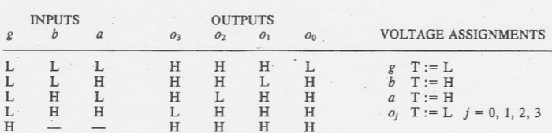Voltage Table for Multiplexor [1]

Short Form Truth Table for Multiplexor

|  |  |  |  |
| --- | --- | --- | --- |
| g | b | a | Z |
| L | L | L | j0 |
| L | L | H | j1 |
| L | H | L | j2 |
| L | H | H | j3 |
| H | x | x | L |

Voltage Table for Decoder [1]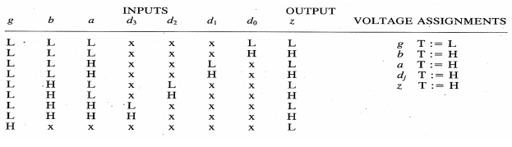

Truth Table for Decoder

|  |  |  |  |  |  |  |
| --- | --- | --- | --- | --- | --- | --- |
| Input | | | Output | | | |
| g | b | a | O3 | O2 | O1 | O0 |
| 1 | 0 | 0 | 0 | 0 | 0 | 1 |
| 1 | 0 | 1 | 0 | 0 | 1 | 0 |
| 1 | 1 | 0 | 0 | 1 | 0 | 0 |
| 1 | 1 | 1 | 1 | 0 | 0 | 0 |
| 0 | - | - | 0 | 0 | 0 | 0 |

## Karnaugh Maps

N/A

## Original and Derived Equations

74LS10 3 Input NAND Gate

$$Y=\overline{ABC}$$

74LS04 Hex Inverter

$$Y=\overline{A}$$

74LS20 4 Input NAND Gate

$$Y=\overline{ABCD}$$

Decoder

$$O0=\overline{gba}$$

$$O1=\overline{gb}a$$

$$O2=\overline{ga}b$$

$$O3=\overline{g}ba$$

Multiplexor

$$Z=\overline{gbad0}+ \overline{gb}ad1+\overline{ga}bd2+\overline{g}abd3$$

## Schematics

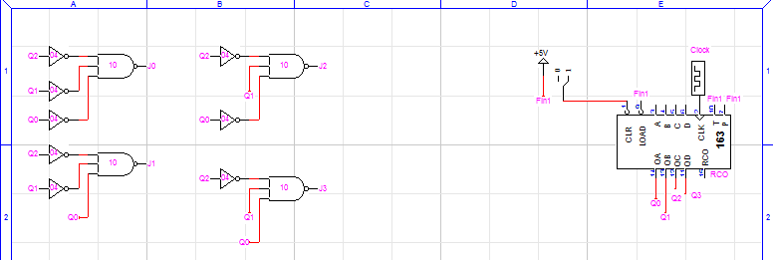Schematic 1: Decoder

The outputs are j0-3 and inputs being the 163’s outputs.

Schematic 2: Multiplexor

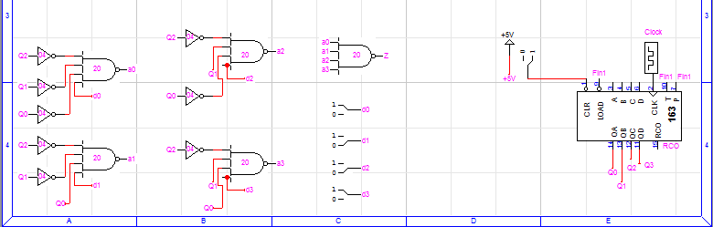

The outputs is Z and inputs being the 163’s outputs.

# testing procedures

1. Using the given voltage table’s equations must be found for the outputs for both tables.
2. Create circuits in Logic Works simulation software.
3. Check to see if the waveforms from the simulation match voltage table.
4. Compare waveforms for correct simulation.

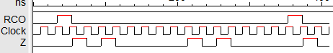Waveform 1: Multiplexor Simulation

Waveform 2: Multiplexor Simulation LHLH

Waveform 3: Multiplexor Simulation HHLL

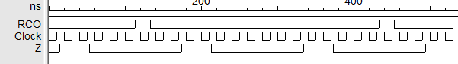

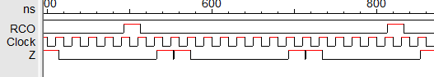Waveform 4: Multiplexor Simulation HLLH

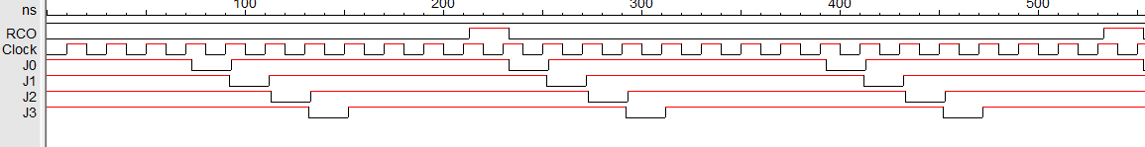Waveform 5: Decoder Simulation

# testing results

Comparing waveform 2-4 we can see that the multiplexor is working ideally as the outputs on the oscilloscope match the output waveforms from the simulation. This shows when a certain input from the clock is provided along with a certain input from the dip switches will cause a certain output. This shows that that the multiplexer can input multiple signals and the output can be controlled by using the select input. The decoder main purpose is to get a signal and decode it by turning into a 2n output signal. The decoder and multiplexor both worked as the voltage table and equations are concluded corrected by looking at the waveforms.

# Conclusion

The lab introduced two new types of circuits called the decoder and multiplexor. Both with have different function s but are two mix-logic circuits that are fundamentally important when comes to digital design. The multiplexer has multiply inputs where the output is determined by the selection input. This means many devices can be all connected to one network without causing problems as the multiplexor will output data from each input when it is needed. The decoder takes multiple signal inputs but decodes them and outputs all of the decoded signals. Both decoder and multiplexer are used in every day architecture with these combinational circuits many limitations have been broken.

# appendices and references

[1] Özemek, Haluk. (2014, Aug 14). 124_Labs [Online].

Available:https://sjsu.instructure.com/courses/1142847/files

1. Anahit Sarao, indianvip60@gmail.com